Appendix D - Instructions for importing structured data from DistillerSR into SRDR

Introduction

The purpose of this document is to provide step-by-step instructions for the process of importing structured data from DistillerSR into the Systematic Review Data Repository (SRDR). Note that this feature is only available in the newest version of SRDR, i.e., SRDR+. However, for simplicity purposes and to be consistent with the rest of this report, this Appendix uses the term SRDR.

There are three main steps to the process of importing structured data from DistillerSR into SRDR. These steps assume that the user has access to the relevant project in DistillerSR. However, if the user does not have access to Distiller, simply having access to the Section files is sufficient, in which case, the user should proceed directly to Step 3.

The steps described in this document are intended to apply to the end of the process of data extraction in a systematic review, once the data are already extracted in DistillerSR. Currently, once the data are imported into SRDR, we have not yet developed interoperability in the opposite direction (i.e., importing of data extracted in SRDR into DistillerSR).

Clarification of Terms

Before we proceed with describing the steps involved with the importing process, we provide below some explanations/definitions of terms:

- Section - Data extraction forms in SRDR are organized into sections. Also known as a tab, each section refers to a collection of questions/items in the data extraction form.
- Section File - This is a file that is exported from DistillerSR that will ultimately be imported into a corresponding section in SRDR.
- Level - DistillerSR allows users to collect study data in phases, called levels. Each level either contains a form to be filled, or multiple sub-levels. When importing into SRDR, each level is mapped to an extraction form section.

Limitations of Current Importing Options

One limitation with current importing options is related to differences in how DistillerSR and SRDR collect and store systematic review data. For example, SRDR projects contain structured elements such as outcomes, populations, and comparisons that have no counterpart in DistillerSR. This incompatibility makes it difficult to create a fully formed SRDR project by interpreting data exports out of DistillerSR. Instead, when importing data, SRDR creates a barebones version of the project that contains none of the structured element, such as outcomes or comparisons. Rather, SRDR imports each DistillerSR file into a separate data extraction form section, where the data contained in the file are represented as question-answer pairs. The names of the imported extraction form sections are the choice of the user importing the project.
It should also be noted that once a project is imported, additional DistillerSR files cannot be imported subsequently into the same project. Therefore, we strongly recommend that the user export all the data out of DistillerSR and only then begin the import process into SRDR.

Steps of importing structured data from DistillerSR into SRDR

Step 1 of 3 - Exporting a File Containing Study References from DistillerSR

- Go to the DistillerSR Home Page.
- Log into your account.
- Use the dropdown at the top of the page to select the project to be exported.
- In the top bar, click on Datarama (Figure 1).

Figure 1

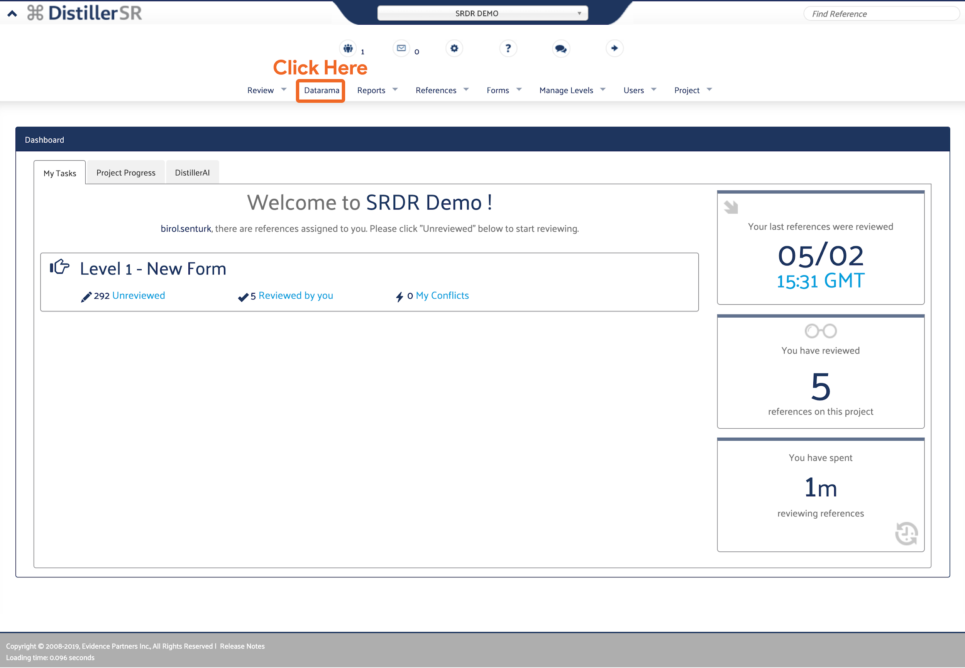

- Click on the Report Settings Tab:
  - Under the Basic Options panel (Figure 2):
    - From the Report Format dropdown, select the RIS option.
    - This step is optional - Enter a filename for the export into the textbox labeled Export File name (optional).
  - Under the Data to Display panel (Figure 2):
    - Ensure that none of the checkboxes are checked.
  - Click on the Reference Display Options Tab and under the Reference Fields panel:
    - Ensure that all checkboxes are selected (Figure 3).
- Click on Run Report at the bottom left of the page to start the export.

Figure 2

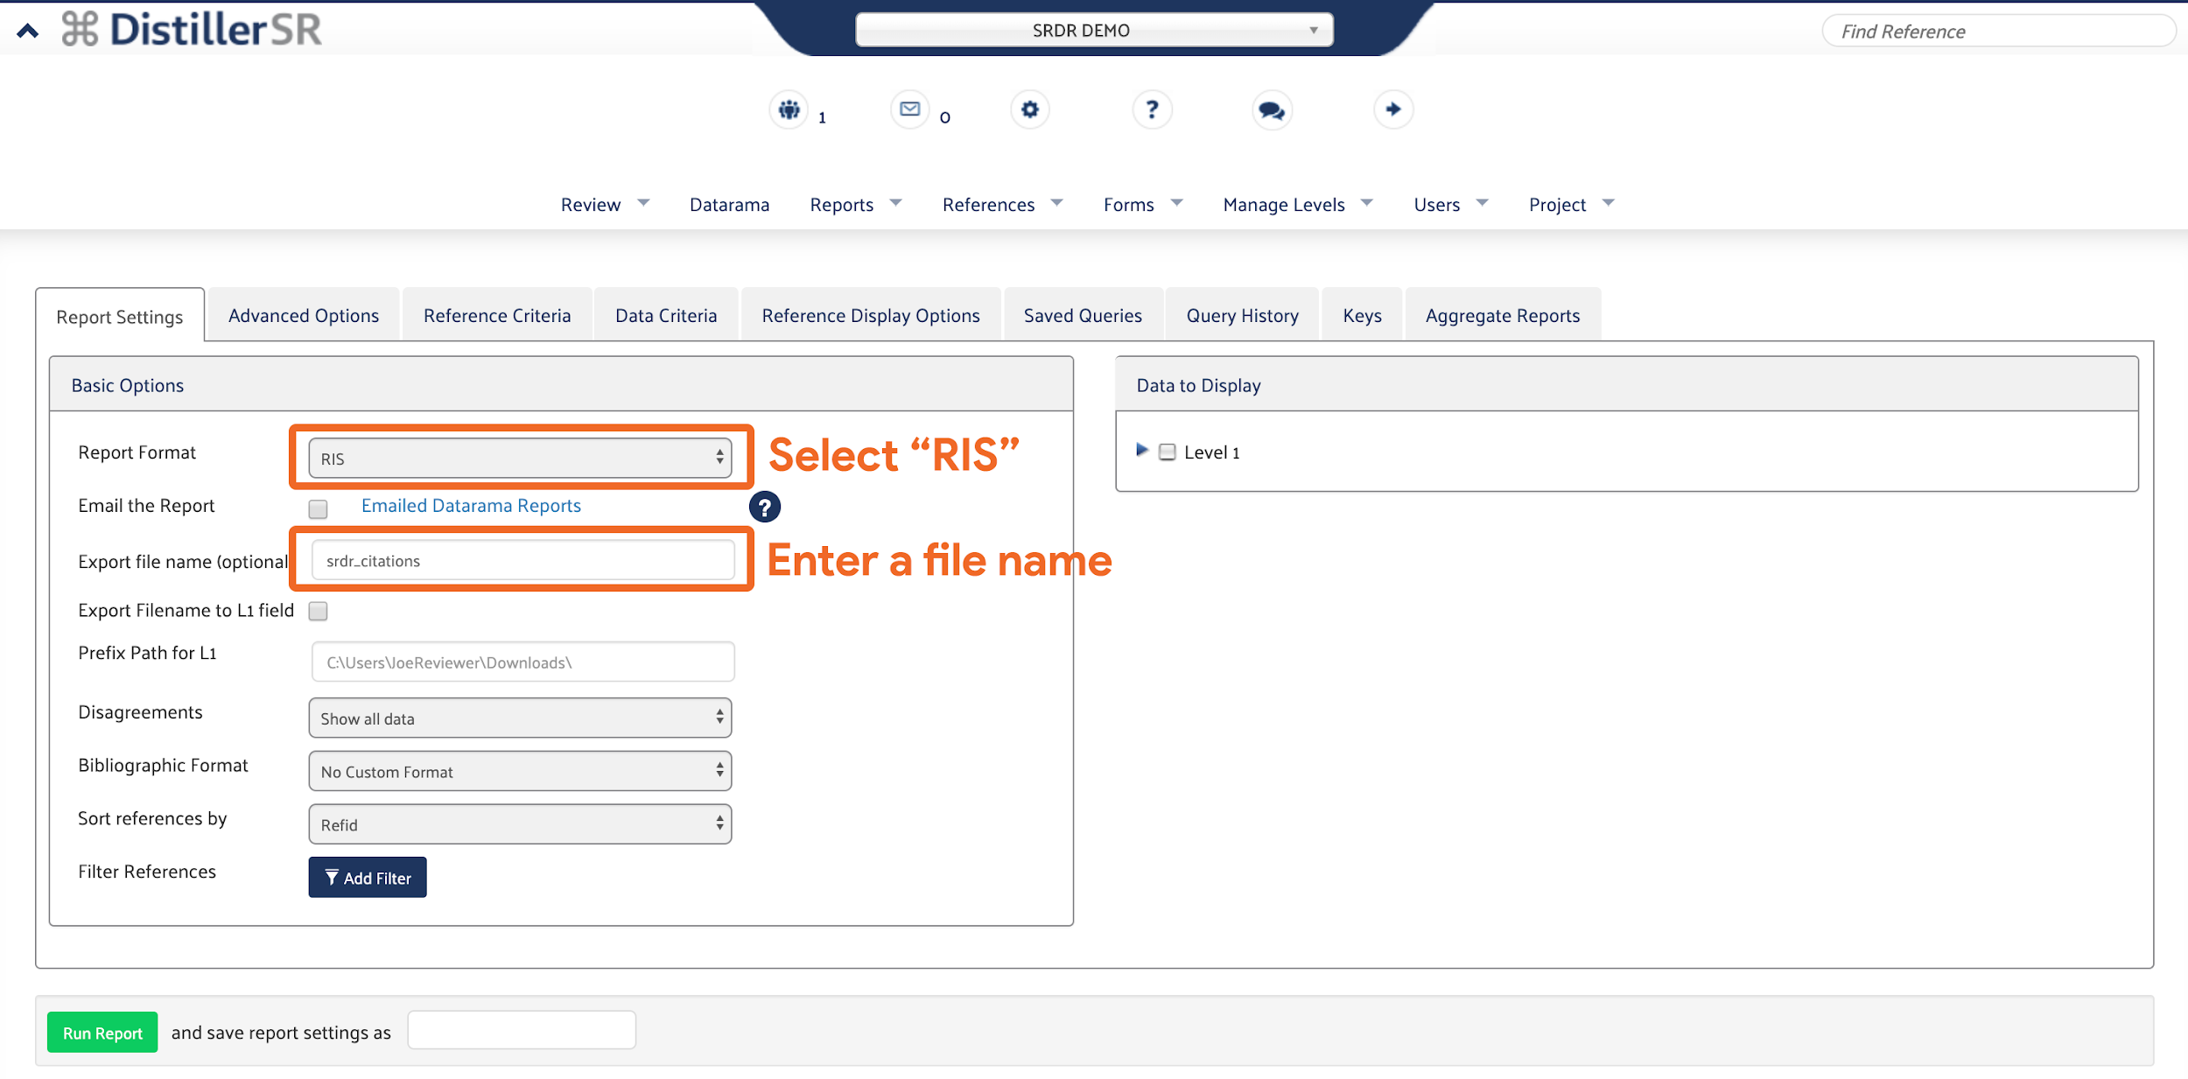

Figure 3

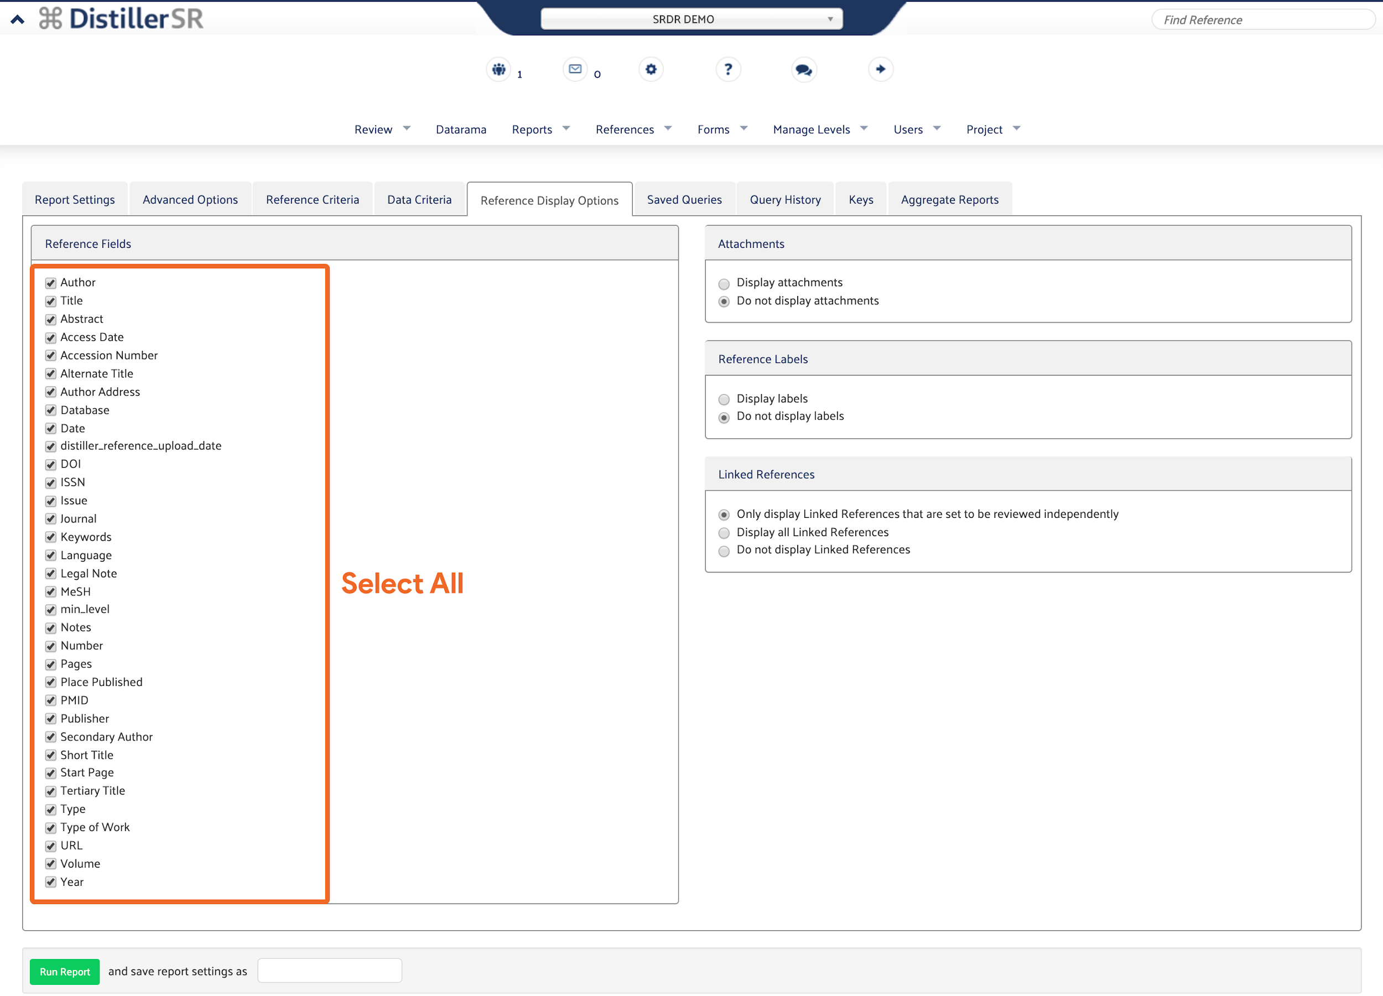

Step 2 of 3 - Exporting Section File(s) from DistillerSR

- Go to the DistillerSR Home Page.
- Log into your account.
- Use the dropdown at the top of the page to select the project to be exported.
- In the top bar, click on Datarama.
- Go to the Report Settings Tab:
  - Under the Basic Options panel (Figure 4):
    - From the Report Format dropdown, select the CSV option.
    - Enter a filename for the export into the textbox labeled Export File name(optional). This step is optional.
  - Under the Data to Display panel (Figure 4):
    - Click on the checkbox next to the level you want to export.
    - Ensure that only one checkbox is selected.

Figure 4

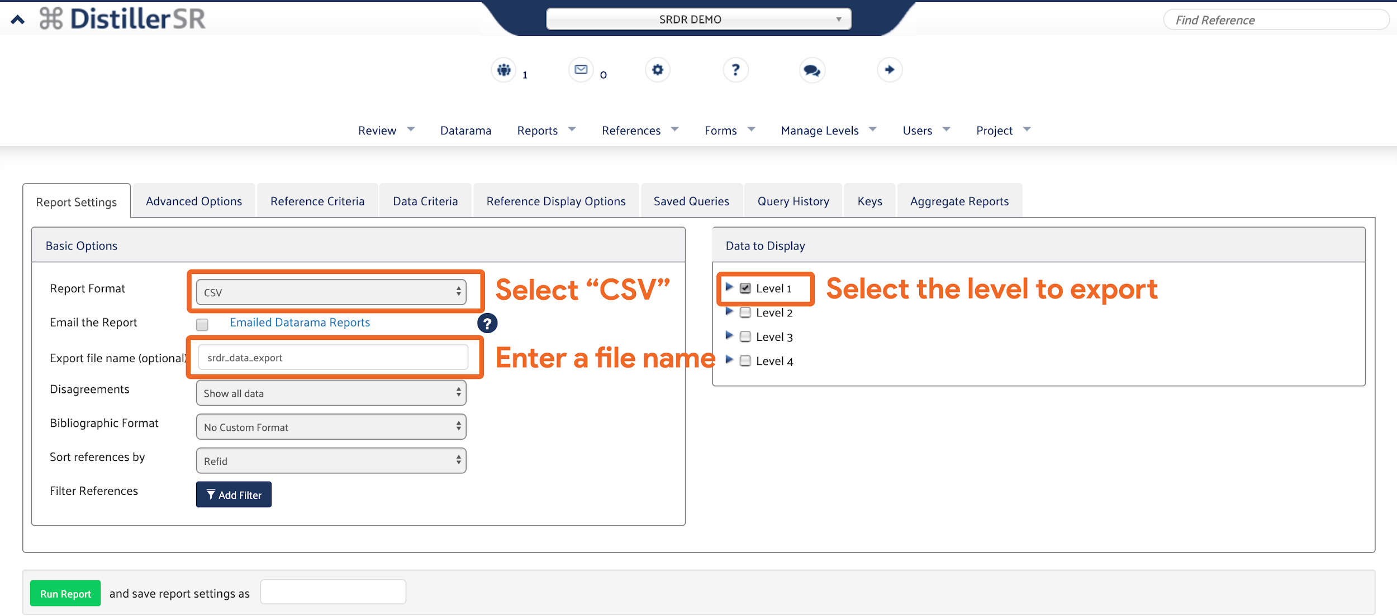

- Go to Advanced Options Tab:
  - Under the Advanced Options panel (Figure 5):
    - Click on the checkbox labeled Merge Sets by Key.
    - Click on the checkbox labeled Show RefIDs of linked references.
    - Ensure that none of the other checkboxes are checked.

Figure 5

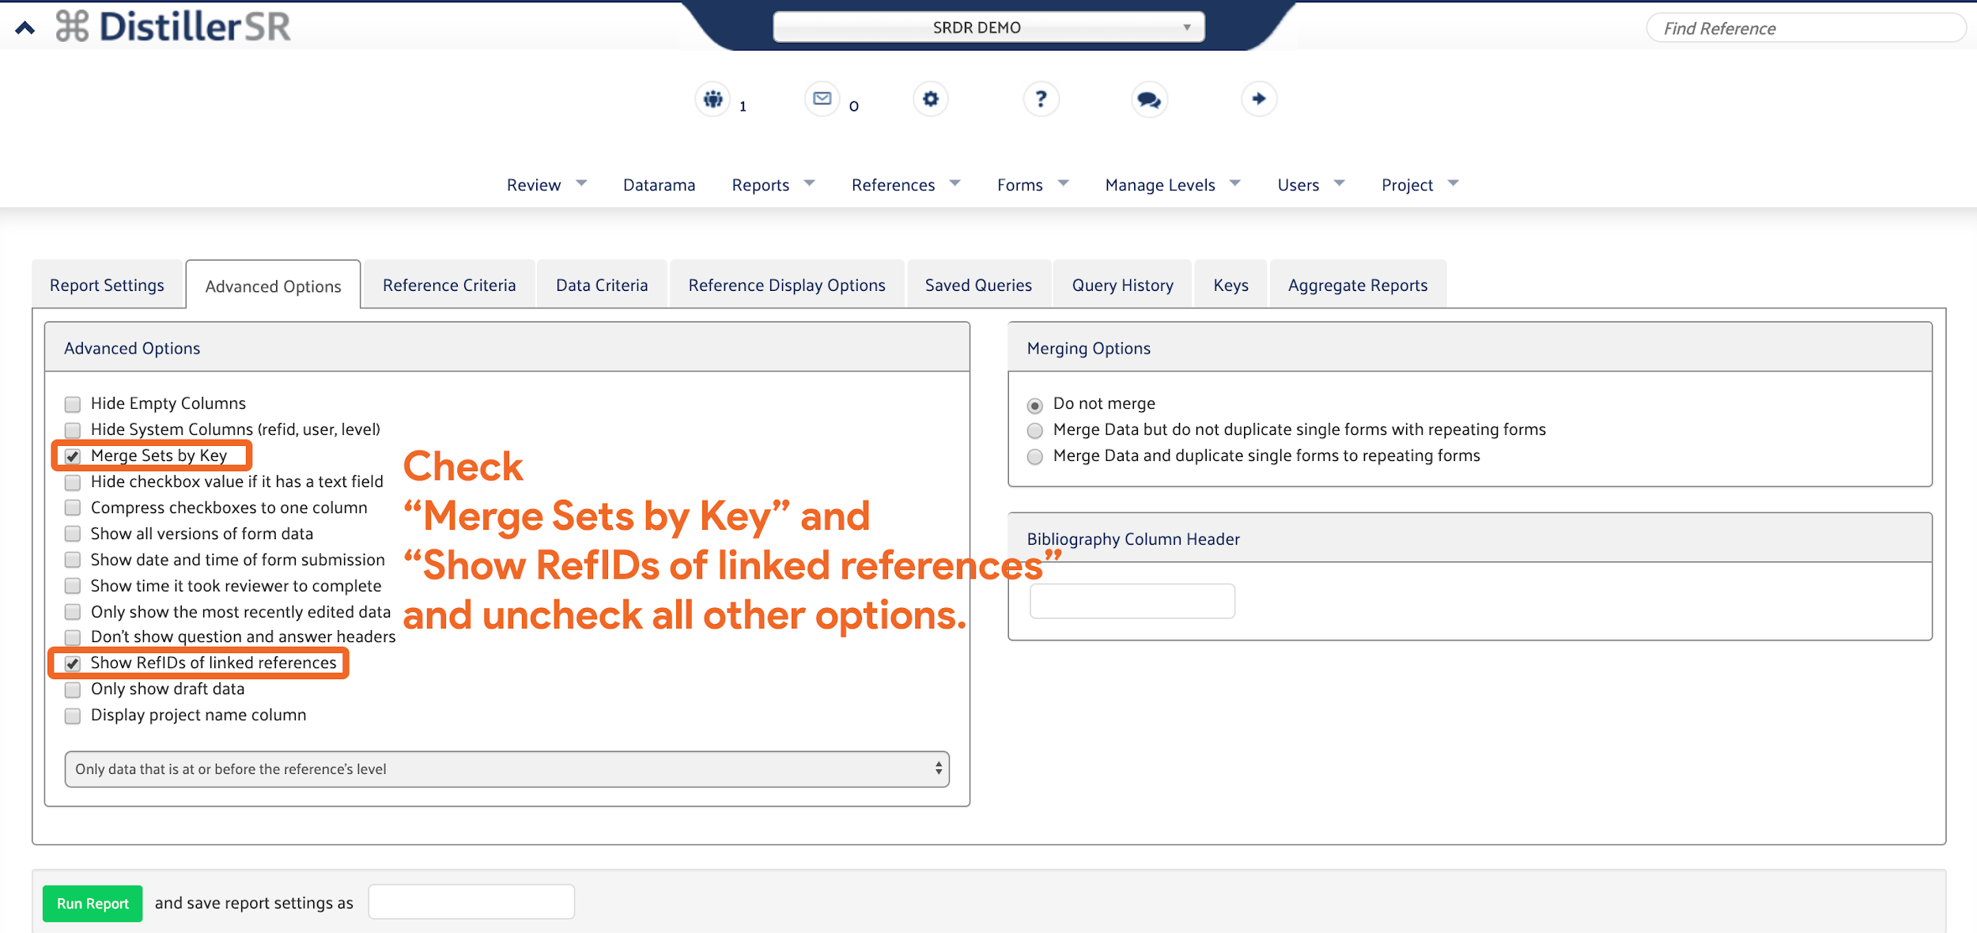

- Click on Run Report at the bottom left of the page to start the export.
- Repeat steps 1 through 8 until all the desired levels are exported as section files.

Step 3 of 3 - Importing the References File and Section File(s) into SRDR
- Go to the SRDR Home Page (https://srdrplus.ahrq.gov).
- Log into your account.
- Click on Dashboard at the top bar.
- Click on Create Project at the top right (Figure 6).

Figure 6

- Enter a name for the imported project using the textbox labeled Name.
- This step is optional - Enter a description for the imported project using the textbox labeled Description.
- Click on the dropdown that says Create an empty project and then select the option to “Create a project from a Distiller SR .csv export” (Figure 7).

Figure 7

- Under the Distiller References File panel (Figure 8):
  - Click on Choose File, then select the References File exported from DistillerSR.
  - Ensure that selected File Type is .ris.

Figure 8

- Under the Distiller Section File panel:
  - Click on the Choose File button (or Browse... button on Firefox), and then select a Section File exported from DistillerSR (Figure 9).

Figure 9

  - Click on the dropdown labeled Key Question and type in the key question addressed by the Section File (Figures 10 and 11).You can also select from the previously entered key questions by clicking on the dropdown option.

Figure 10

Figure 11

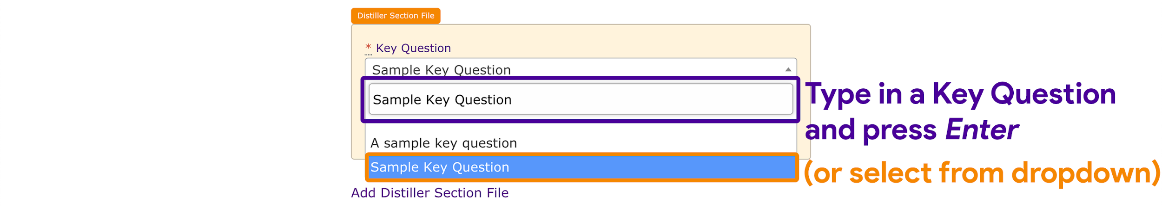

  - Click on the dropdown labeled Section and type in a name for the extraction form section (Figure 11 and 12). You can also select from the defaults by clicking on the dropdown option.

Figure 12

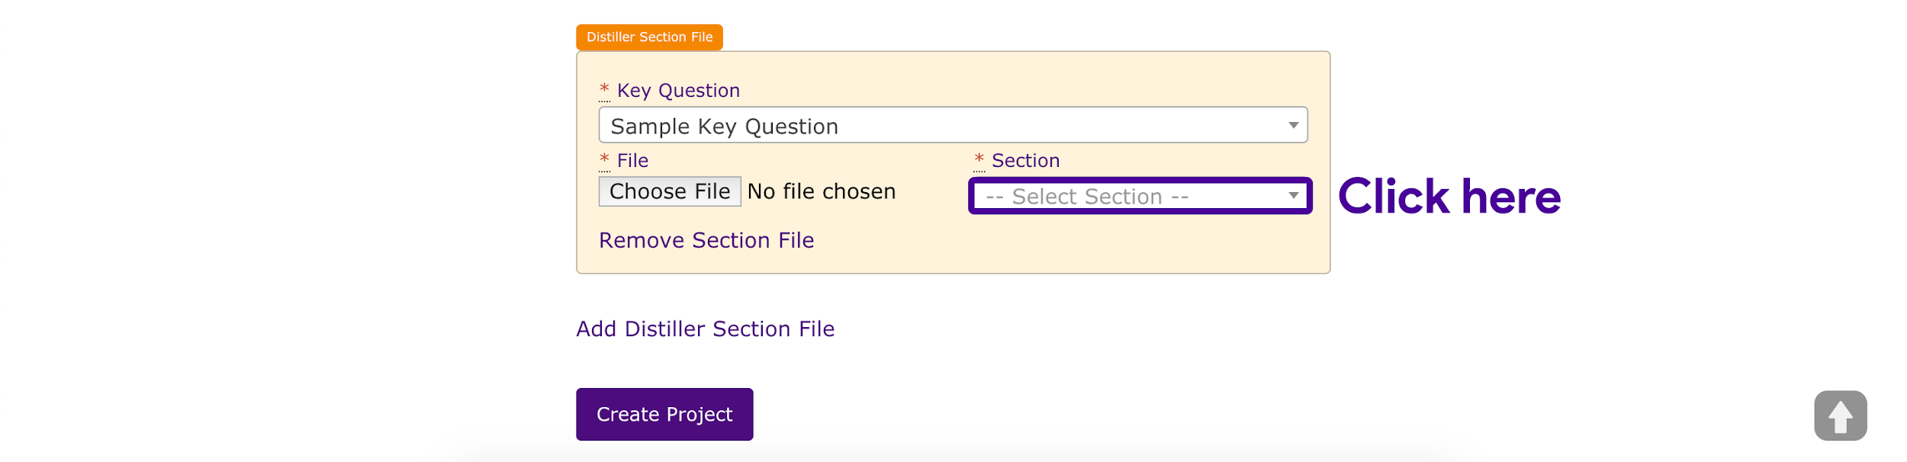

Figure 13

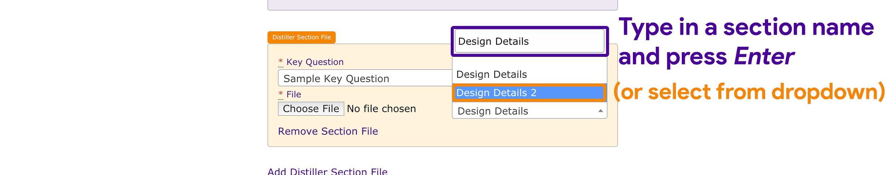

- If there are additional Section Files to import, click on the Add Distiller Section File link and repeat Step 7 (Figure 14).

Figure 14

- Click on Create Project to start the import (Figure 15). A green notification will appear indicating that the import is being processed (Figure 16).

Figure 15

Figure 16

